Chapter12 Periodic Table name: class:
1. 了解Alkali metal 的物理性质和化学性质(metallic)
Alkali metal ：GroupⅠ elements
物理性质：
1. Soft ( can be cut easily) 2. Lighter than most metal 3.Low melting point
化学性质：Metallic (金属性) ：The ability of a particle to lose electrons
1. React rigorously with water: 2 Li + 2 H₂O → 2 LiOH + H₂
2. React rigorously with Chlorine : 2 Li + Cl₂ → 2 LiCl₂
3. React rigorously with oxygen : 4 Li + O₂ → 2 Li₂O
1. What is not a property of Group I metals? （ ）
A They are soft and can be cut with a knife.
B They react when exposed to oxygen in the air.
C They produce an acidic solution when they react with water.
D They react rapidly with water producing hydrogen gas.

2. Group I metal are also known as the Alkali Metals.
Which statement about the metals in Group I is not correct? （ ）
A In their reactions they lose electrons.
B Their atoms all have one electron in their outer shell.
C They form $+1$ ions in their reactions with non- metals.
D They form covalent compounds by sharing electrons.
2. 了解Group Ⅰ中的趋势(density, reactivity, melting point)
第一主族 down the group 从上到下：
1. Higher density 2. Lower melting point 3. More reactive
1. Elements in Group I of the Periodic Table react with water.
Which row describes the products made in the reaction and the trend in reactivity of the elements? （ ）
 | products | trend in reactivity
A | metal hydroxide and hydrogen | less reactive down the group
B | metal hydroxide and hydrogen | more reactive down the group
C | metal oxide and hydrogen | less reactive down the group
D | metal oxide and hydrogen | more reactive down the group
2. Which statement about the elements of Group I is correct? （ ）
A Lithium is more dense than sodium.
B Potassium has a higher density than lithium.
C Potassium is less reactive than sodium.
D Sodium has a higher melting point than lithium.

3. The table shows some properties of the Group I metals.
metal | melting point/℃ | hardness | reaction with water
lithium | 181 | moderately soft | steady effervescence
sodium | 98 | soft | vigorous effervescence
potassium | 63 | very soft | very vigorous effervescence
rubidium | ? | ? | ?
What are the properties of rubidium? （ ）
A melts below ${63}^{∘}C$ very soft, reacts explosively with water
B melts below ${63}^{∘}C$ very soft, reacts slowly with water
C melts above ${181}^{∘}C$ very soft, reacts explosively with water
D melts above ${181}^{∘}C$ very soft, reacts slowly with water
3. 了解Halogen的物理性质和化学性质并能解释其活泼性(non-metallic)
Halogen : Group Ⅶ elements
物理性质： 1. All different colours. 2. Form diatomic molecules
Diatomic molecules:The molecule that contains two atoms
化学性质：1. Non-metallic (非金属性)： The ability to gain electrons
2. Poisonous 有毒
 | Cl₂ | Br₂ | I₂
Colour | Pale yellow-green | Red-brown | Grey-black
State | Gas | Liquid | solid

1. The halogens are a collection of diatomic non- metals in Group VII.
Define the term diatomic. .........................................................................................[1]
(ii) How do their electron distributions differ? ..........................................................[1]
Complete the table.
halogen | solid, liquid or gas at room temperature | colour
chlorine
bromine
iodine
2 .The diagrams show the labels of four bottles.
Which label is not correct? （ ）
A | B | C | D
Bromine | Iodine | Potassium | Sodium
Br₂ | Al | K | Na
Harmful liquid. | Danger | Danger | Danger
Do not spill. | Avoid breathing vapour from the solid. | Store under water. | Store under oil.
4. 掌握Group Ⅶ中的趋势(colour, reactivity, melting point)
第Ⅶ主族 down the group 从上到下
1. The colour of the halogen is darker
2. The melting point is increasing
3. The density is increasing

1. Ununseptium (atomic number 117) is a man- made element that is below astatine in Group VII of the Periodic Table.
What is the expected state of ununseptium at room temperature? （ ）
A a diatomic gas B a liquid C a monatomic gas D a solid

2. Which statement about the halogens and their compounds is correct? （ ）
A The colour of the element gets lighter going down Group VII.
B The elements get less dense going down Group VII.
C When chlorine is added to sodium iodide solution, iodine is formed.
D When iodine is added to sodium bromide solution, bromine is formed.
3. Some properties of four elements, P, Q, R and S, are shown in the table.
Two of these elements are in Group I of the Periodic Table and two are in Group VII.
element | reaction with water | physical state at room temperature
P | reacts vigorously | solid
Q | does not react with water | solid
R | reacts explosively | solid
S | dissolves giving a coloured solution | liquid
Which statement is correct? （ ）
A P is below R in Group I. B Q is above R in Group I.
C Q is below S in Group VII. D R is below S in Group VII.
5. 掌握Halogen 与Halides 之间的displacement reaction (Reactivity series)
Displacement reaction(置换反应)：
More reactive Halogen displace the less reactive halide ion
更活泼的卤素单质夺取不活泼的卤族离子的位置
2 Br⁻ + Cl₂ → 2 Cl⁻ + Br₂
2 I⁻ + Cl₂ → 2 Cl⁻ + I₂

1. Fluorine is at the top of Group VII in the Periodic Table.
Which row shows the properties of fluorine? （ ）
 | colour | state at room temperature | reaction with aqueous potassium iodide
A | brown | gas | no reaction
B | brown | liquid | iodine displaced
C | yellow | gas | iodine displaced
D | yellow | liquid | no reaction

2. Element X is in Group VII of the Periodic Table.
It reacts with aqueous potassium bromide as shown.
$$X_{2}+2KBr→2KX+{Br}_{2}$$
Which statements about X are correct? （ ）
 | relative atomic mass | reactivity
A | greater than that of bromine | less reactive than bromine
B | greater than that of bromine | more reactive than bromine
C | less than that of bromine | less reactive than bromine
D | less than that of bromine | more reactive than bromine

3. Which statement about the halogens and their compounds is correct? （ ）
A The colour of the element gets lighter going down Group VII.
B The elements get less dense going down Group VII.
C When chlorine is added to sodium iodide solution, iodine is formed.
D When iodine is added to sodium bromide solution, bromine is formed.

4. The halogens are the elements in Group VII of the Periodic Table.
Predict the physical state and colour of astatine at room temperature and pressure. physical state colour
.........................................................................................................................................................................................................................................................................[2]
When chlorine reacts with aqueous potassium bromide a displacement reaction occurs.
Describe the colour change of the solution. from to................................................. [2]
Write a chemical equation for this reaction...................................................... [2]
Reactions occur when some aqueous solutions of halogens are added to aqueous solutions of halides.
Use the key to complete the table to show the results of adding halogens to halides.
key $\sqrt{​}=$ reaction $x=$ no reaction
 |  | halides
 |  | KCl(aq) | KBr(aq) | KI(aq)
halogens | Cl2(aq) |  | ✓
 | Br2(aq)
 | I2(aq)

6. 掌握一个周期中从左到右的趋势(Charge of ions, reactivity, boiling point)
在一个周期中，从左到右：
1. Charge of ions (离子电荷) +1 ， +2， +3 ， +4/-4 ， -3 ，-2 ，-1 ，0
2. Reactivity: Group 1 to 3 less metallic ;Group 5 to 7 more non-metallic
3. Properties of oxides : Basic oxide to amphoteric oxide to acidic oxide
1. Which property of elements increases across a period of the Periodic Table?（ ）
A metallic character
B number of electron shells
C number of outer shell electrons
D tendency to form positive ions

2. Which statement about the Periodic Table is correct?（ ）
A Elements in the same period have the same number of outer electrons.
B The elements on the left are usually gases.
C The most metallic elements are on the left.
D The relative atomic mass of the elements increases from right to left.

3. Which statements about Group I and Group VII elements are correct?（ ）
1 In Group I, lithium is more reactive than potassium.
2 In Group VII, chlorine is more reactive than fluorine.
 | statement 1 | statement 2
A | ✓ | ✓
B | ✓ | ×
C | × | ✓
D | × | ×
4. Part of the Periodic Table is shown.
Which element forms an oxide that reacts with dilute acid to form a salt and water? （ ）
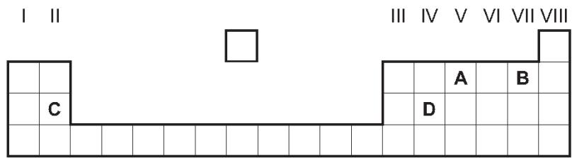

7. 掌握Transition metal 中在元素周期表中的位置
1. An element melts at ${1455}^{∘}C$ has a density of $8.90g/cm^{3}$ and forms a green chloride.
Where in the Periodic Table is this element found? （ ）
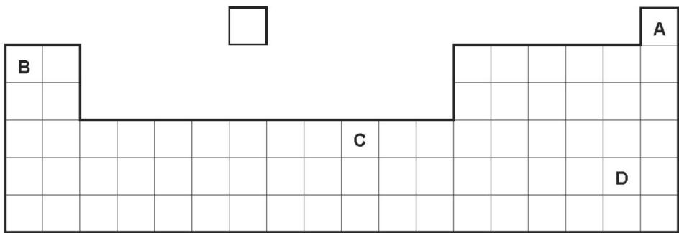

8. 掌握Transition metal 的物理性质和用途
性质：1. High density 2. High melting point 3. Form coloured compounds
4. Having ions of variable oxidation number
用途：Act as catalyst as elements and compounds

1. An element X has the two properties listed.
1 It acts as a catalyst.
2 It forms colourless ions.
Which of these properties suggest that X is a transition element? （ ）
 | property 1 | property 2
A | ✓ | ✓
B | ✓ | x
C | x | ✓
D | x | x
2.The table gives information about four elements.
Which element is a transition metal? （ ）
 | colour of element | electrical conductivity of element | colour of oxide
A | black | high | colourless
B | colourless | low | white
C | grey | high | red
D | yellow | low | colourless

3. Osmium is a transition element.
Which row gives the expected properties of osmium? （ ）
 | melting point | density | compounds formed
A | high | high | coloured
B | high | high | white
C | high | low | white
D | low | high | coloured

4. Iron(II) ions can be oxidised to iron(III) ions by hydrogen peroxide.
Which statement explains why iron is a transition element? （ ）
A Iron is a transition element because it can be oxidised.
B Iron is a transition element because it has variable oxidation states.
C Iron is a transition element because it takes part in redox reactions.
D Iron is a transition element because it reacts with chlorine.

5. Which metal has variable oxidation states? （ ）
A aluminium B calcium C copper D sodium
9. 掌握稀有气体的性质，并且能从电子排布角度解释稀有气体的性质
1. Helium is a noble gas.
Which statement about helium is correct? （ ）
A It has eight electrons in its outer shell.
B It is a diatomic gas.
C It is reactive.
D It is used for filling balloons.

2. Which diagram shows a mixture of noble gases? （ ）
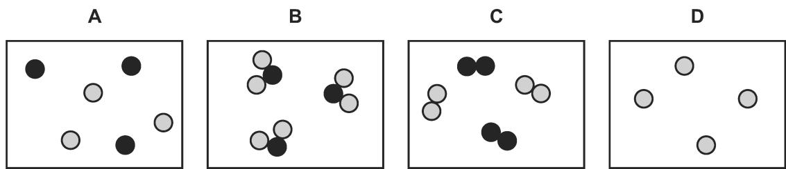

10. 掌握从元素在元素周期表中的位置推测其物理性质和化学性质
1. Part of the Periodic Table is shown.
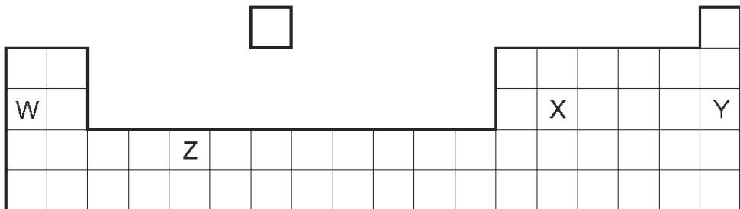
Which row correctly describes the properties of elements W, X, Y and Z? （ ）
 | has variable oxidation states | reacts with cold water | very unreactive | has four outer shell electrons
A | W | Y | Z | X
B | X | W | Y | Z
C | Z | W | Y | X
D | Z | Y | X | W

2. Some properties of element X are shown.
melting point in℃ | 98
boiling point in℃ | 883
reaction with cold water | gives off H₂ gas
reaction when heated with oxygen | burns to give a white solid
In which part of the Periodic Table is X found? （ ）
A Group I B Group VII C Group VIII D transition elements

3. Part of the Periodic Table is shown.
Element Q has a low boiling point, low density and does not conduct electricity.
Which element is Q? （ ）
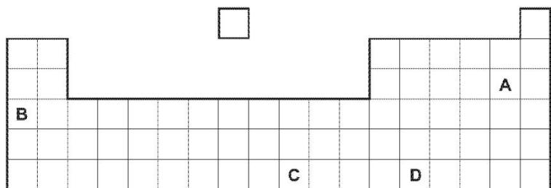
4. The table below gives the electron distributions of atoms of different elements.
element | electron distribution
A | 2 + 7
B | 2 + 8 + 4
C | 2 + 8 + 8 + 1
D | 2 + 8 + 18 + 5
E | 2 + 8 + 18 + 7
F | 2 + 8 + 18 + 18 + 8
For each of the following, select an element or elements from the table that matches the description. Each element may be selected once, more than once or not at all.
These two elements are in the same group. .....................................................[1]
This element forms a fluoride with a formula of the type $XF_{3}$ ...............................[1]
This element reacts violently with cold water. ...........................................................[1]
This element has a macromolecular structure similar to that of diamond. ...............[1]
The only oxidation state of this element is 0............................................................. [1]
This element is bromine. ..........................................................................................[1]
This element is a good conductor of electricity......................................................... [1]
11. 掌握元素周期表的排列规则，各部分元素的名称。
1. Which element is classified as a non- metal in the Periodic Table? （ ）
A calcium B chlorine C chromium D copper

2. Element X is a non- metal.
In which position of the Periodic Table could element X be found? （ ）
A at the bottom of Group I
B at the top of Group 0
C at the top of Group I
D in the transition elements

3. Part of the Periodic Table is shown.
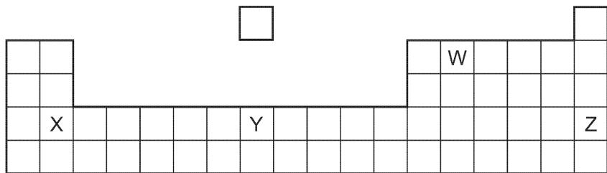
Which row describes W, X, Y and Z? （ ）
 | metal | non-metal
A | X | W, Y and Z
B | X and Y | W and Z
C | W and Z | X and Y
D | W, Y and Z | X

4. In the outline of the Periodic Table below, some elements are shown as numbers.
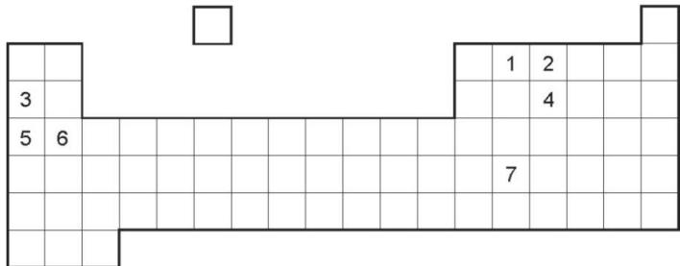
Which two numbers are metals in the same period? （ ）
A 1 and 2 B 1 and 7 C 3 and 5 D 5 and 6
5. An element, X, is a dark grey crystalline solid at room temperature.
It has a melting point of ${114}^{∘}C$ and a density of $4.9g/cm^{3}$
When heated gently it forms a purple vapour.
Where in the Periodic Table is X found? （ ）
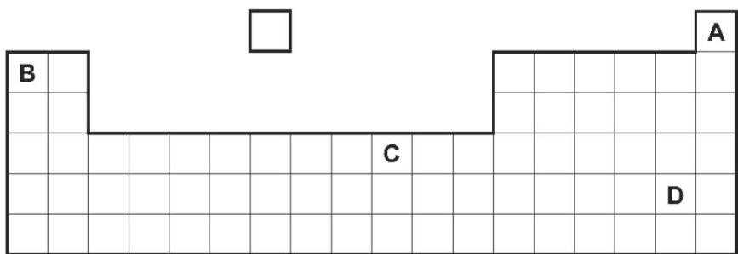
6. In the Periodic Table, the elements are arranged in columns called Groups and in rows called Periods.Complete the table for some of the elements in Period 3.
group number | I | II | III | IV | V | VI | VII
symbol | Na | Mg | Al | Si | P | S | Cl
number of valency electrons
valency
[2]
What is the relationship between the group number and the number of valency electrons?.......................................................................................................................
Explain the relationship between the number of valency electrons and the valency for the elements Na to Al, for the elements P to Cl.
.......................................................................................................................
Across a period, the elements change from metallic to non-metallic.
Describe how the type of oxide changes across this period.
.......................................................................................................................
.......................................................................................................................
Describe how the type of bonding in the chlorides formed by these elements changes across this period.
......................................................................................................................
......................................................................................................................[2]

